**Python Flask Application**

First Make RDS MYSQL DATBASE

After launching the database connect to database  
first Launch ec2 instance and install commands  
 **1- sudo su**

**2 curl https://packages.microsoft.com/config/rhel/7/prod.repo > /etc/yum.repos.d/msprod.repo**

**3 sudo curl https://packages.microsoft.com/config/rhel/7/prod.repo > /etc/yum.repos.d/msprod.repo**

**4 sudo yum install -y mssql-tools**

**5 sudo apt update**

**6- sudo apt install mysql-client**

**7 mysql -h dbadmin123-instance-1.c1fzffy39xml.us-east-1.rds.amazonaws.com -u dbadmin123 -p**

After connect to RDS database using this command

**mysql -h dbadmin123-instance-1.c1fzffy39xml.us-east-1.rds.amazonaws.com -u dbadmin123 -p**

Then create a database

**CREATE DATABASE dbadmin123;**

**USE dbadmin123;**

**CREATE TABLE MyUsers (**

**id INT AUTO_INCREMENT PRIMARY KEY,**

**firstname VARCHAR(50) NOT NULL,**

**lastname VARCHAR(50) NOT NULL**

**);**

Then go to code and run these commands  
Make sure already installed the python in your laptop

**Pip install -r requirements.txt**

**Python app.py**

When your application is running   
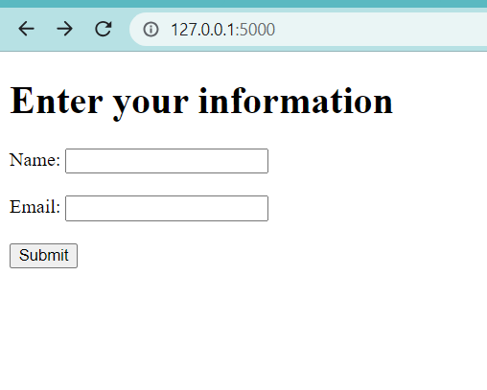

Put data and submit the button

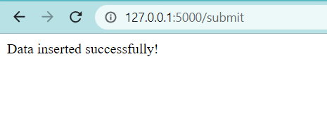

Go to database instance and check data is reached or not

Select * form MyUsers

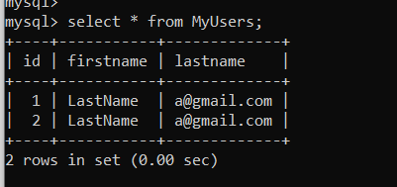

GO to postman and test these getData

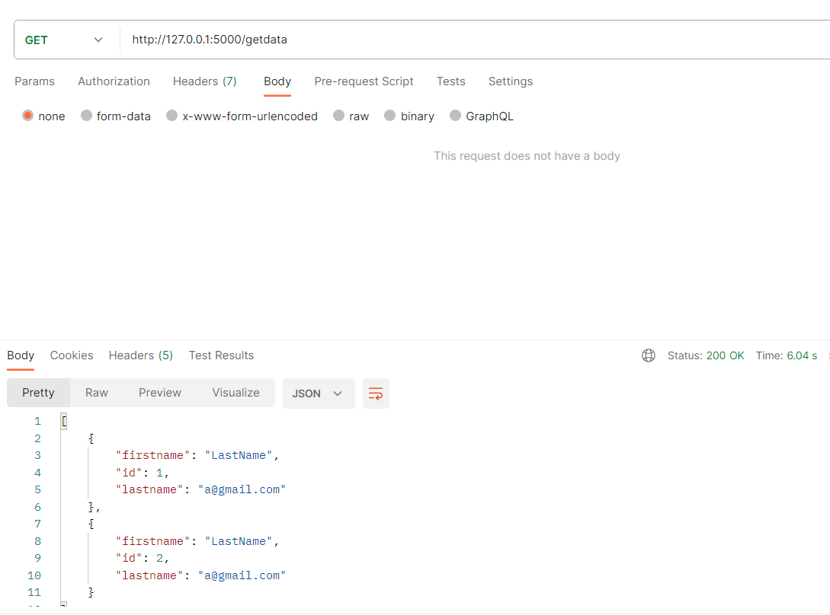

Also delete

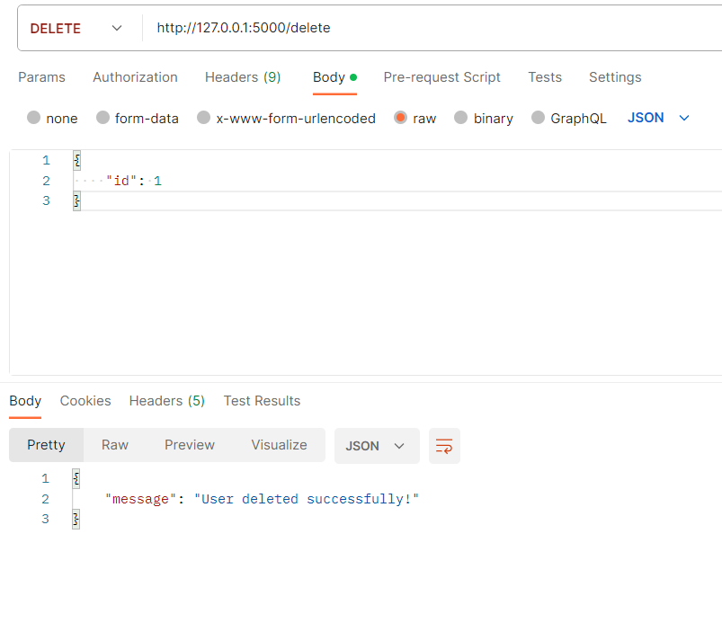

Here is the update  
